



**Consultancy Services For DEVELOPMENT OF UNIVERSAL PENSION SCHEME PROGRAM (ZUPS) ZANZIBAR**

**USER MANUAL**

**VERSION 1**

**SUBMMITED BY :**

**WEB TECHNOLOGIES TANZANIA LIMITED**

**WEB TECHNOLOGIES (T) LTD, BRANCHES: DAR ES SALAAM | ZANZIBAR | ARUSHA | MBEYA |IRINGA | TANGA |**

**MOSHI | MOROGORO |MWANZA | TABORA | MUSOMA | MTWARA |SONGEA | LINDI | KIGOMA | MARA | KAGERA**

CONTENTS

Part A: ZUPS MIS Platform 6

1 OVERVIEW 6

1.1 Purpose 6

1.2 Audience 6

1.3 Document Conventions 6

1.4 About the ZUPS MIS and Mobile App Experience 6

1.5 Hardware and Software Requirements 6

2 GETTING STARTED 6

2.1 Logging into your account 6

2.2 Exploring the Homepage & Navigation 6

2.3 The Menu Items 6

2.4 Change Language 6

2.5 Exploring the Home page & Navigation 6

3 ZUPS MIS INITIAL SETUPS 6

3.1 Beneficiaries Setup 6

3.1.1 Setting up Zones 6

3.1.2 Setting up Zones 6

3.1.3 Setting up Shehias 6

3.1.4 Setting up Shehas 7

3.2 Setting up Employee Accounts 7

3.2.1 Setting up Department 7

3.2.2 Setting up Units 7

3.1.3 Assigning Roles 7

3.1.4 Creating new employees 7

3.3 Setting up Employee Accounts 7

3.3.1 Creating Payment Station 7

3.3.2 Summary List of Payment 7

3.3.3 Shehias in Payment Stations 7

4 MANAGING BENEFICIARIES 7

4.1 Creating new beneficiaries 7

4.1.1 Editting supplementary beneficiary data 7

4.1.2 Beneficiary Waiting Vetting 7

4.1.3 Beneficiary Waiting Approval 7

4.1.4 Total List Beneficiary 7

4.1.5 Beneficiary Fingerprints Data 7

4.2 Assigning Next of Kins 7

4.2.1 Editing supplementary beneficiary data 7

4.2.2 Total List Beneficiary 8

4.2.3 Next of Kins Fingerprint Data 8

4.3 Beneficiary and Next of Kin Master Archive 8

4.4 Beneficiary Setups 8

5 BUDGETING 8

5.1 Generating A New Budget 8

5.1.1 Budget Summary 8

5.2 Vouchers 8

5.2.1 Voucher Generation 8

5.2.2 Printing of Vouchers 8

5.3 New Budget Items 8

5.3.1 Adding New Entries 8

5.3.2 Entry Categories 8

5.4 Budget Evaluation 8

5.5 Budget Payment Status 8

6 CASH BOOK 9

6.1 Accounting 9

6.1.1 Posting In Individual Legders 9

6.1.2 Managing Ledges 9

6.1.3 Setups 9

7 PAYMENT TRANSACTIONS 9

7.1 Cash Allocation 9

7.1.1 Allocation for Beneficiaries 9

7.1.2 Allocation for Officers 9

7.1.3 Assigned Cashiers 9

7.2 Cash Transactions 9

7.2.1 Allowance for Officers 9

7.2.2 Cashier Accounts Transactions 9

7.3 Payment against budget 9

7.3.1 Posting payment transaction 9

7.3.2 Suppliers Information 9

7.4 Beneficiary Payment Data 10

7.4.1 Beneficiary Awaiting Payment 10

7.4.2 Beneficiary Payed 10

7.4.3 Beneficiary Summary Report 10

7.4.4 Beneficiary Expired Payments 10

7.5 Closing Payment Transaction 10

7.5.1 Pending Transactions 10

7.5.2 Closed Transactions 10

7.5.3 All Transactions 10

7.5.4 Amount Summary per Payment Station 10

8 INVENTORY 10

8.1 Stationary Stock 10

8.1.1 Confirming Stock 10

8.1.2 Issuing Stock 10

8.2 Fuel Management 10

8.2.1 Fuel Confirmation 10

8.2.2 Fuel Dispersion 10

9 REPORTING 11

9.1 Monthly Reports 11

9.2 Statistical Data 11

9.3 Beneficiary Master Archive 11

9.4 Custom Reports 11

10 COMPLAINTS MANAGEMENT 11

10.1 Registering Complaint 11

10.2 Managing Complaint 11

11 VEHICLE MANAGEMENT 11

11.1 Managing Vehicles 11

11.2 Route Assignment 11

12 DOCUMENT MANAGEMENT 11

12.1 Manage Folder 11

12.2 Manage Documents 11

13 CUSTOM FEATURES IN USER ACCOUNTS 12

13.1 Data Clerk 12

13.2 Pension Clerk 12

13.3 Cashiers 12

13.4 Cashier In Charge 12

13.5 Head Universal Pension Officer 12

13.6 Stores (Inventory & OS) 12

13.7 Chief Accountant 12

13.8 Auditors 12

13.9 System Administrators 12

14 SYSTEM SETUP & CONFIRGURATION 13

14.1 Automation Settings 13

14.2 Events 13

14.3 Audit Trail 13

14.4 ZUPS Settings 13

14.5 Users 13

14.6 Manage Permissions 13

14.7 Manage User Roles 13

Part B: ZUPS Mobile Application Platform 13

15 GETTING STARTED ON APPLICATION 13

15.1 Logging in into the app 13

15.4.1 Opening the ZUPS Mobile app 13

15.4.2 15.2 Registering account 13

15.4.2 15.2 Logging in 13

15.2 Exploring the Homepage & Navigation 13

15.4.1 The Menu Items 13

15.4.2 The SideBar 13

16 DATA CAPTURE 14

16.1 Completing Registration 14

16.1.1 Beneficiary Search 14

16.1.2 Fingerprint and photo capture 14

16.2 Check offline registry data 14

16.3 Death Registry 14

17 PAYMENT 14

17.1 Verify and Pay 14

17.2 Payment Process 14

17.2.1 Receipt Generation 14

17.3 Check offline payment data 14

Appendix A – Staying Secure 14

Appendix B – Frequently Asked Questions 14

Index 14

# Part A: ZUPS MIS Platform

# OVERVIEW

## Purpose

## Audience

## Document Conventions

## About the ZUPS MIS and Mobile App Experience

## Hardware and Software Requirements

# GETTING STARTED

## Logging into your account

## Exploring the Homepage & Navigation

## The Menu Items

## Change Language

## Exploring the Home page & Navigation

# ZUPS MIS INITIAL SETUPS

## Beneficiaries Setup

### 3.1.1 Setting up Zones

3.1.2 Setting up Zones

### 3.1.3 Setting up Shehias

### 3.1.4 Setting up Shehas

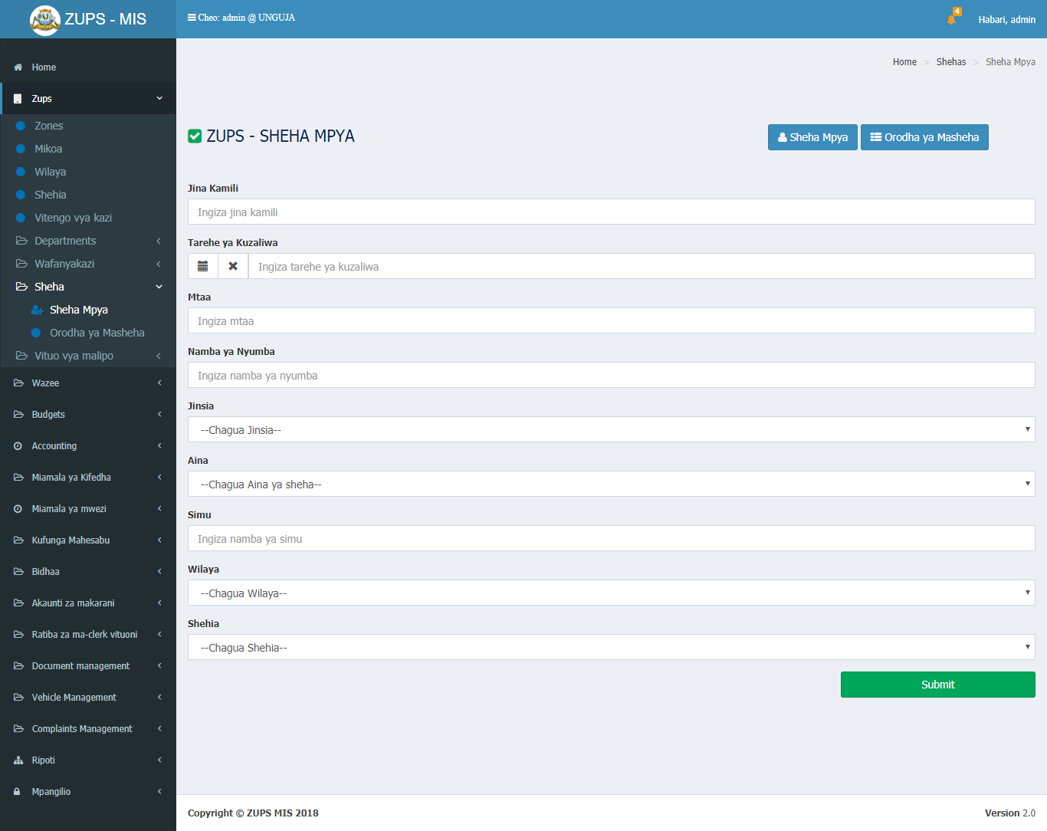

## Setting up Employee Accounts

### 3.2.1 Setting up Department

### 

### 3.2.2 Setting up Units

### 

### 3.1.3 Assigning Roles

### Creating new employees

## 3.3 Setting up Employee Account

## 3.3.1 Creating Payment Station

### 3.3.2 Summary List of Payment

### 

### 3.3.3 Shehias in Payment Stations

# MANAGING BENEFICIARIES

## Creating new beneficiaries

### 

### 4.1.1Editting supplementary beneficiary data

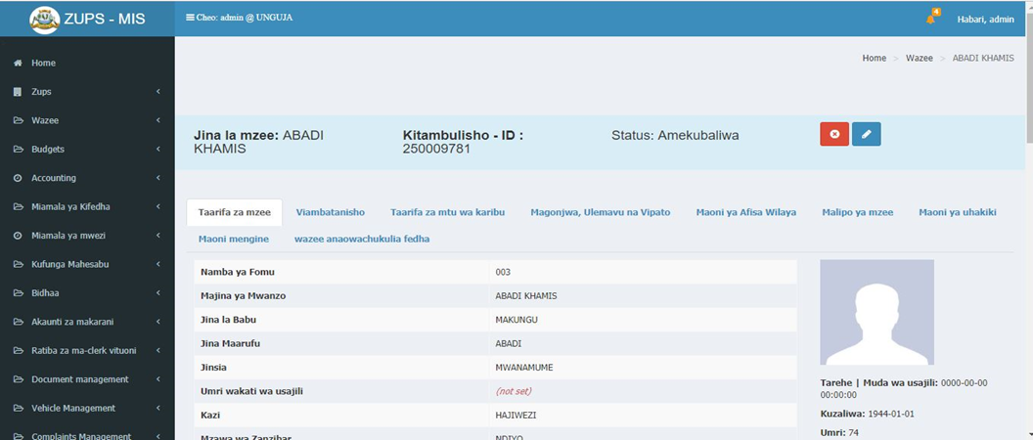

### 4.1.2 Beneficiary Waiting Vetting

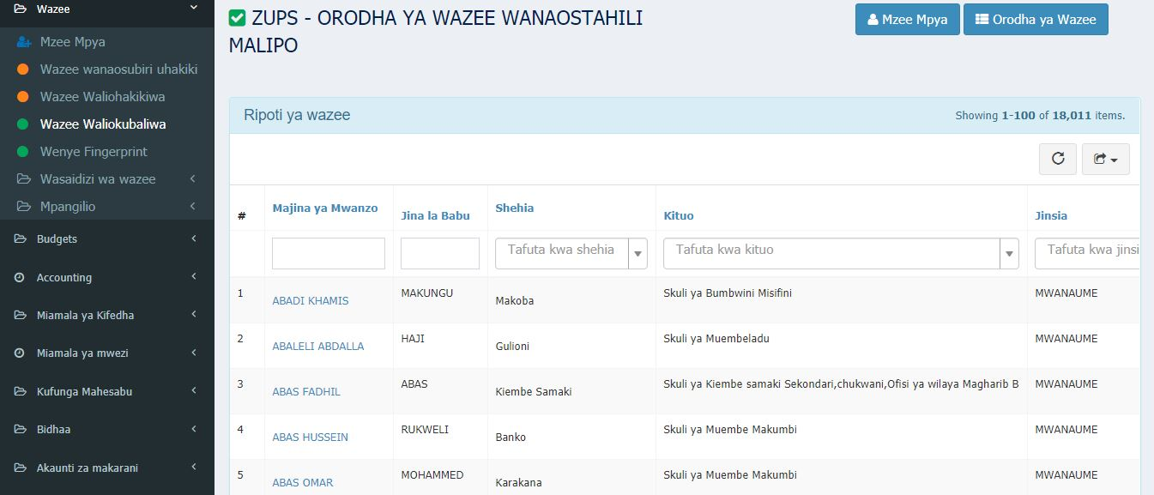

### 4.1.3 Beneficiary Waiting Approval

### 4.1.4 Total List Beneficiary

### 4.1.5 Beneficiary Fingerprints Data

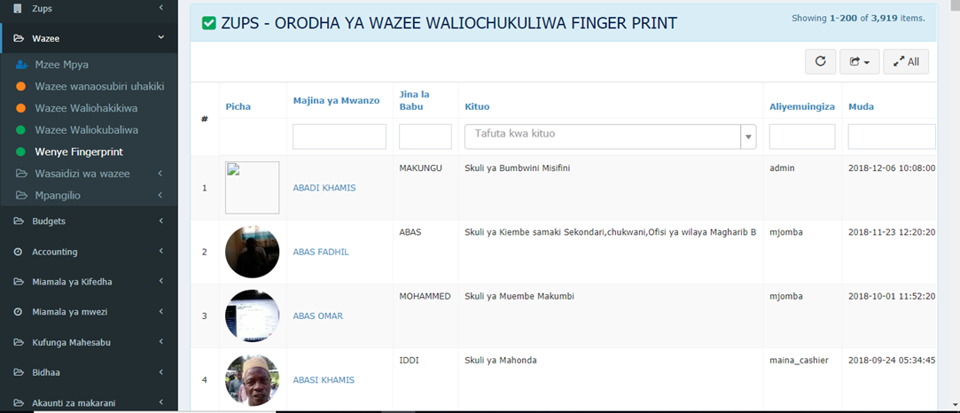

## Assigning Next of Kins

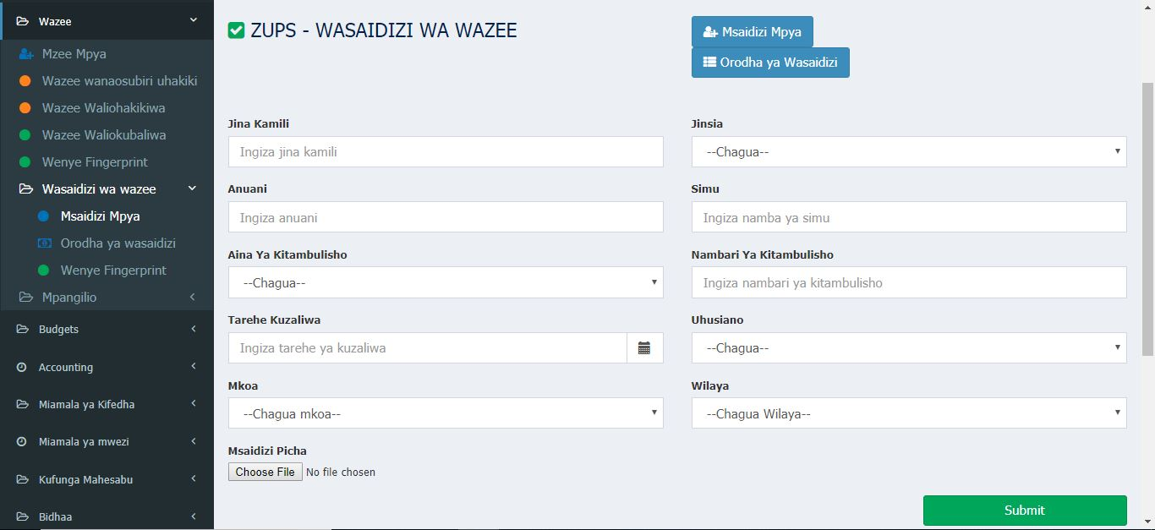

### 4.2.1 Editing supplementary beneficiary data

### 

### 4.2.2 Total List Beneficiary

### 

### 4.2.2 Total List Beneficiary

### 

### 4.2.3 Next of Kins Fingerprint Data

## 

## Beneficiary and Next of Kin Master Archive

## Beneficiary Setups

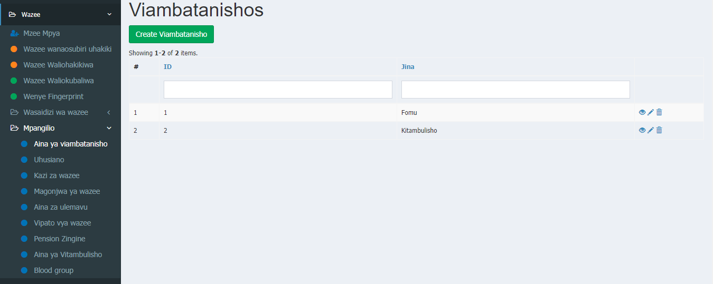

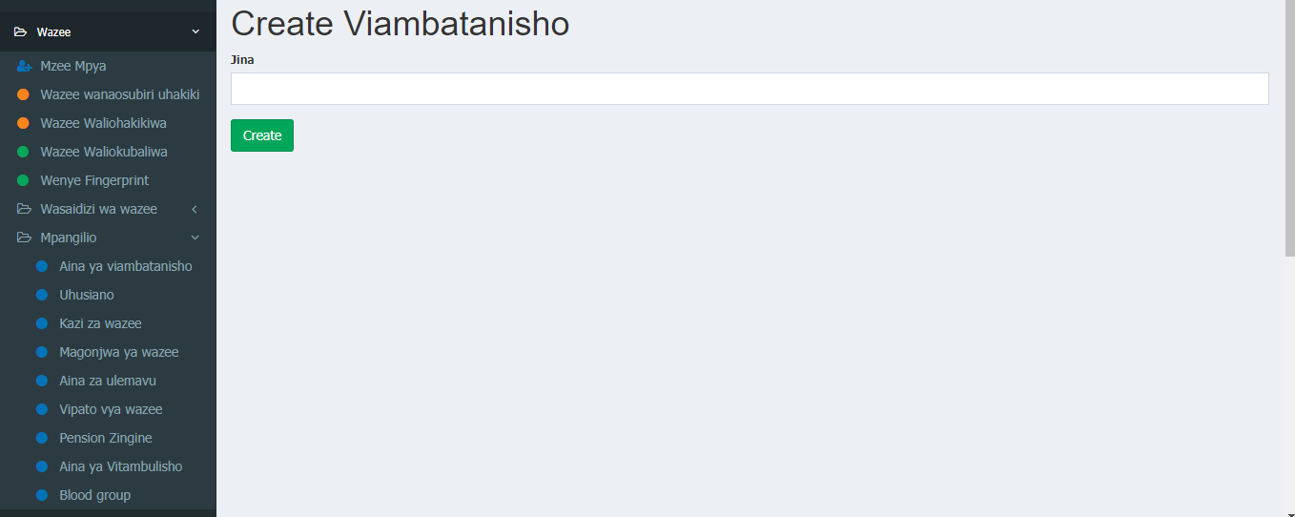

# BUDGETING

## Generating A New Budget

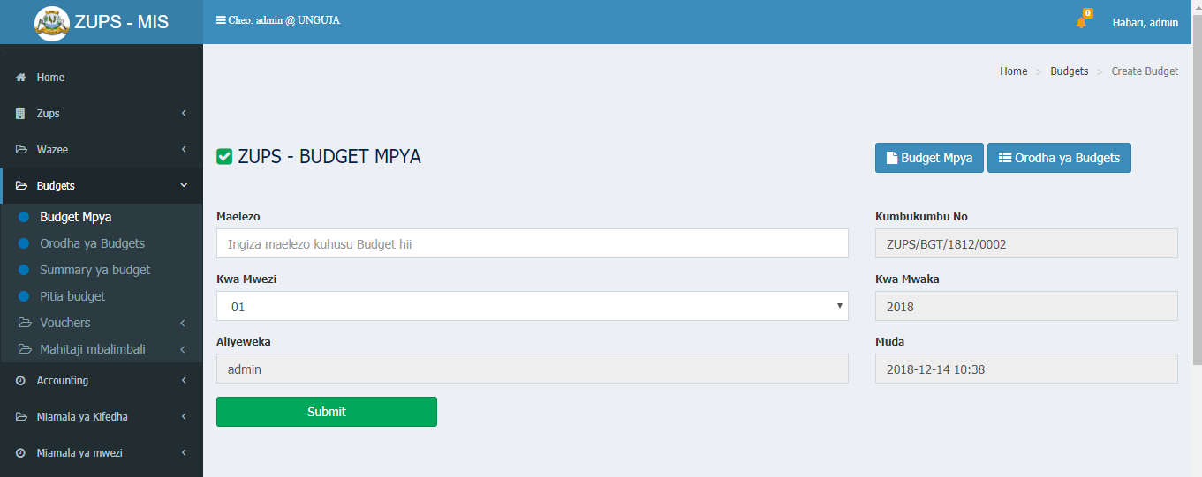

### 5.1.1 Budget Summary

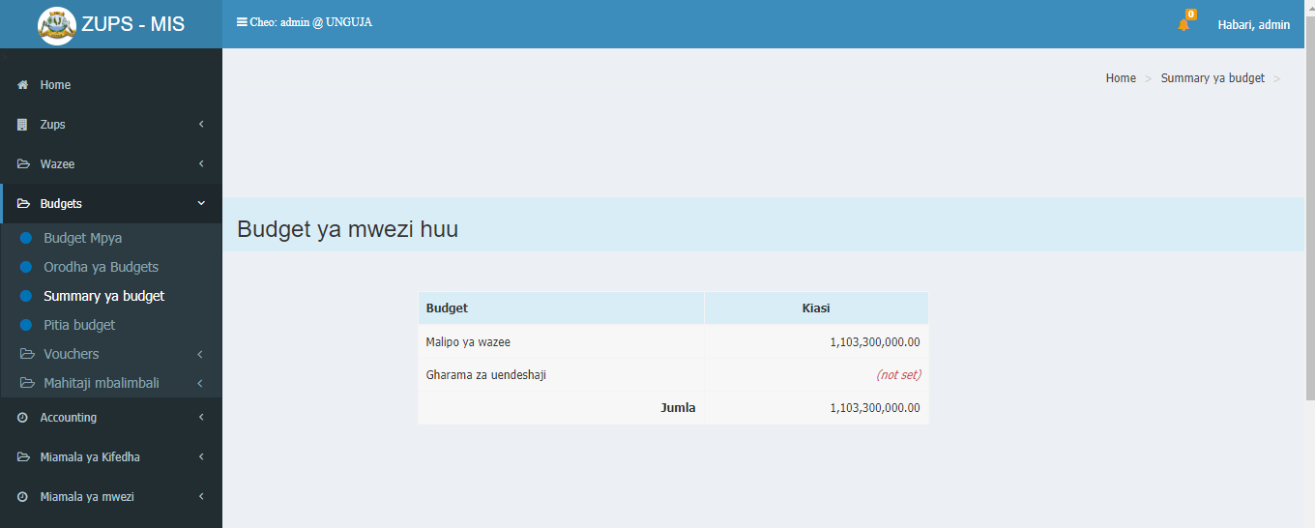

## Vouchers

### 5.2.1 Voucher Generation

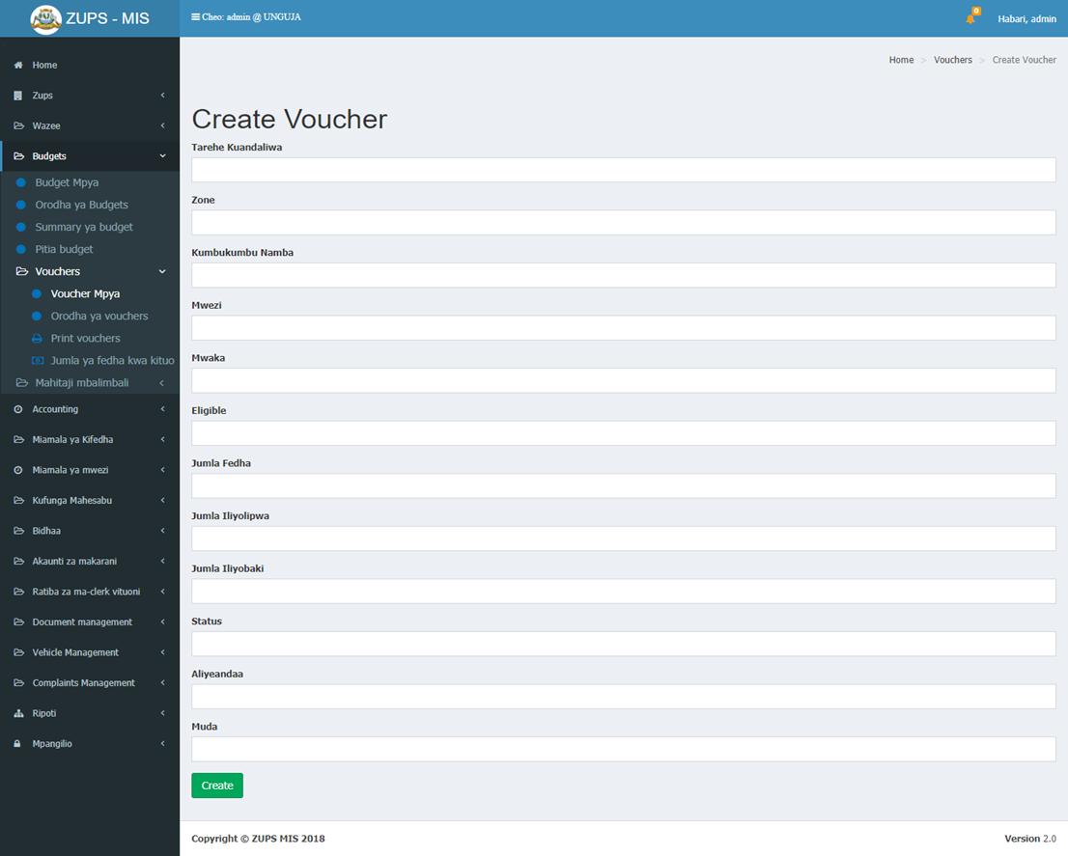

### 5.2.2 Printing of Vouchers

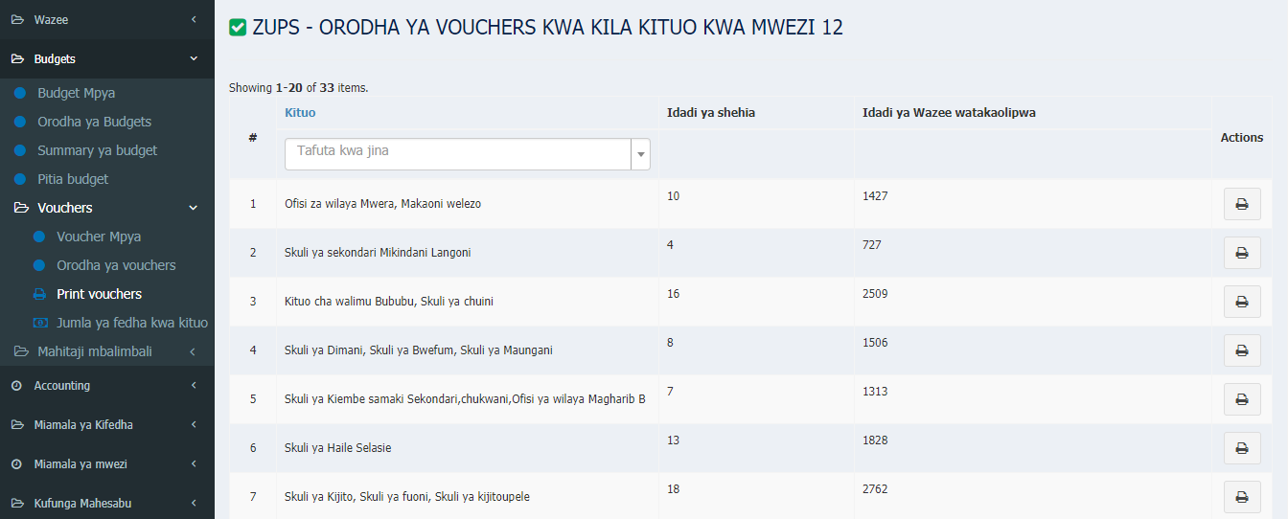

Bado kwenye Mfumo

## New Budget Items

### 5.3.1 Adding New Entries

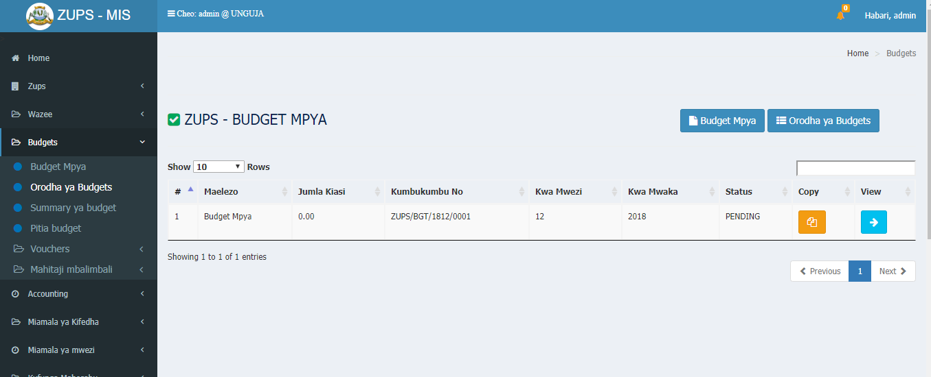

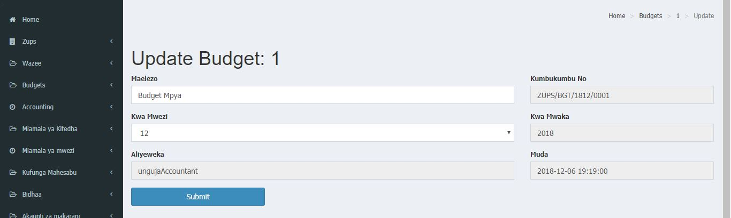

### 5.3.2 Entry Categories

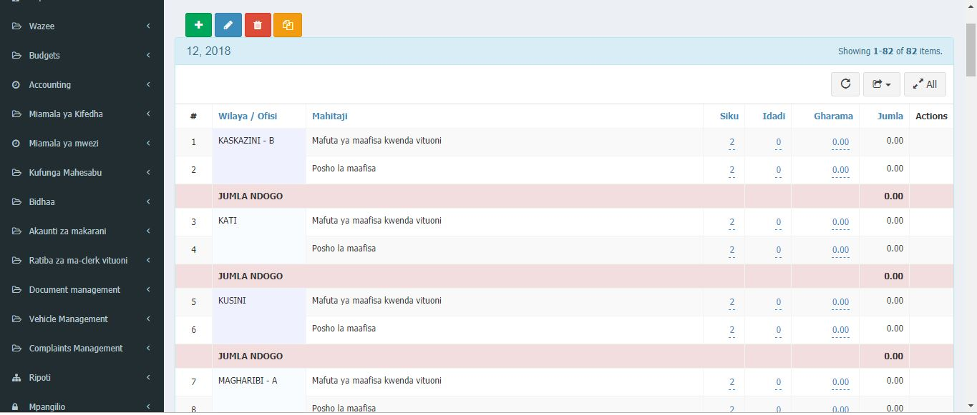

## Budget Evaluation

## Budget Payment Status

# CASH BOOK

## Accounting

### 6.1.1 Posting In Individual Legders

### 6.1.2 Managing Ledges

### 6.1.3 Setups

# PAYMENT TRANSACTIONS

## Cash Allocation

### 7.1.1 Allocation for Beneficiaries

### 7.1.2 Allocation for Officers

### 7.1.3 Assigned Cashiers

## Cash Transactions

### 7.2.1 Allowance for Officers

### 7.2.2 Cashier Accounts Transactions

## Payment against budget

### 7.3.1 Posting payment transaction

### 7.3.2 Suppliers Information

## Beneficiary Payment Data

### 7.4.1 Beneficiary Awaiting Payment

### 7.4.2 Beneficiary Payed

### 7.4.3 Beneficiary Summary Report

### 7.4.4 Beneficiary Expired Payments

## Closing Payment Transaction

### 7.5.1 Pending Transactions

### 7.5.2 Closed Transactions

### 7.5.3 All Transactions

### 7.5.4 Amount Summary per Payment Station

# INVENTORY

## Stationary Stock

### 8.1.1 Confirming Stock

### 8.1.2 Issuing Stock

## Fuel Management

### 8.2.1 Fuel Confirmation

### 8.2.2 Fuel Dispersion

# REPORTING

## Monthly Reports

## Statistical Data

## Beneficiary Master Archive

## Custom Reports

# COMPLAINTS MANAGEMENT

## Registering Complaint

## Managing Complaint

# VEHICLE MANAGEMENT

## Managing Vehicles

## Route Assignment

# DOCUMENT MANAGEMENT

## Manage Folder

## Manage Documents

# CUSTOM FEATURES IN USER ACCOUNTS

## Data Clerk

## Pension Clerk

## Cashiers

## Cashier In Charge

## Head Universal Pension Officer

## Stores (Inventory & OS)

## Chief Accountant

## Auditors

## System Administrators

# SYSTEM SETUP & CONFIRGURATION

## Automation Settings

## Events

## Audit Trail

## ZUPS Settings

## Users

## Manage Permissions

## Manage User Roles

# Part B: ZUPS Mobile Application Platform

# GETTING STARTED ON APPLICATION

## Logging in into the app

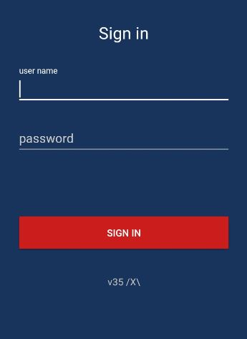

### 15.4.1 Opening the ZUPS Mobile app

### 15.4.2 15.2 Registering account

### 15.4.2 15.2 Logging in

## Exploring the Homepage & Navigation

### 15.4.1 The Menu Items

### 15.4.2 The SideBar

# DATA CAPTURE

## Completing Registration

### 16.1.1 Beneficiary Search

### 16.1.2 Fingerprint and photo capture

## Check offline registry data

## Death Registry

# PAYMENT

## Verify and Pay

## Payment Process

### 17.2.1 Receipt Generation

## Check offline payment data

# Appendix A – Staying Secure

# Appendix B – Frequently Asked Questions

# Index